**ACKNOWLEDGEMENT**

First and foremost, we wish to express our gratitude to the Almighty god for the abundance of wisdom and presence throughout the execution of our project.

We are taking opportunity to express our sincere thanks to our Deputy Director Mr. Sojan Jose with whose permission made this project. We here by acknowledge, with deep sense of gratitude the very valuable advice and guidance of our teacher Mr. Achu Sivadasan and all other teachers for without whose help it would have impossible to complete this project work. We also express our thanks to all other members in the Institution.

Last but not the least we would like to thank the encouragement given by our classmates and others teachers for supporting in hundred title ways that means a lot.

This leaf of acknowledgement would not be complete without special thanks for their normal support encouragement and love, which enabled to successfully bring out this project.

INTRODUCTION

“Reading is the passport to countless adventures”

-Mary Pope Osborne

Book Hub is a online website where customers can read book through a link and it act as intermediate of a website .The user must create an account before logging into the website. They can choose different category of stories at a one click and easily to handle at any time in anywhere. Most of person are not interest to carry book in their bag this website is a solution for their problems. Their is only need of phone to open library they let you travel without moving your feet.

TABLE OF CONTENTS

1. INTRODUCTION
2. IMAGES OF WEBSITE
3. CODES
4. CONCULSION
5. BIBLIOGRAPHY

Login

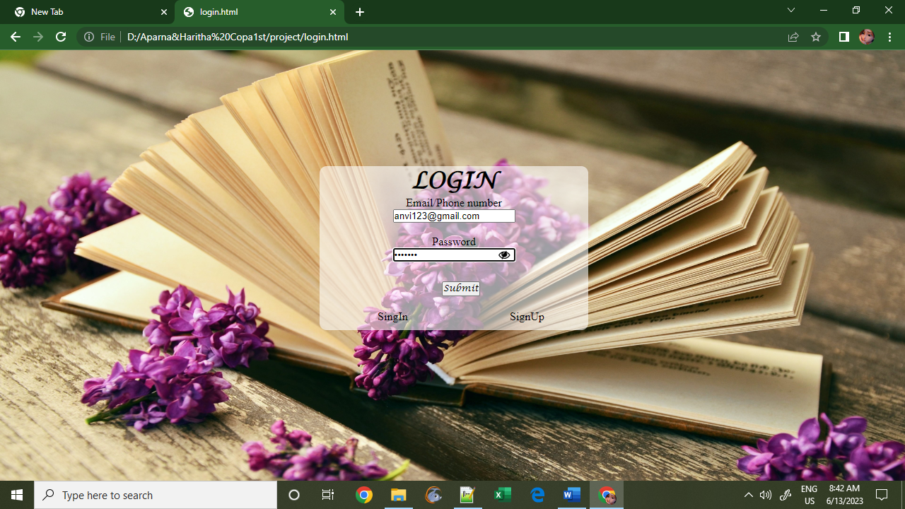

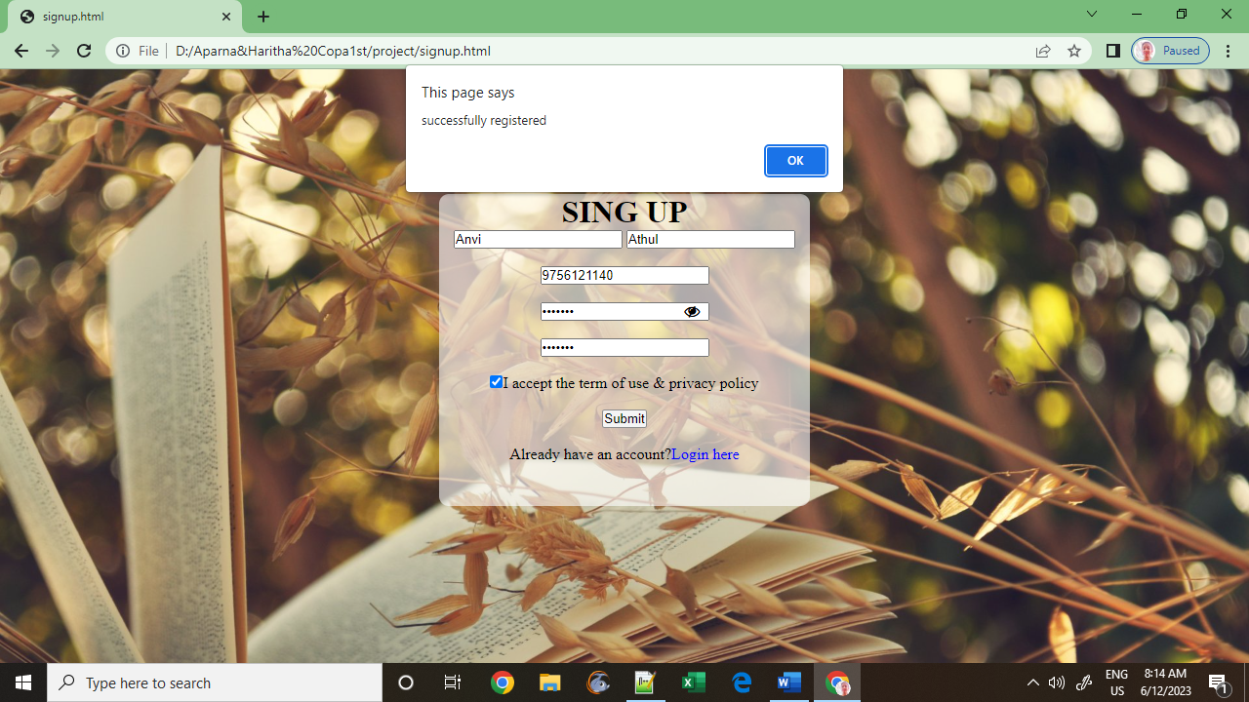

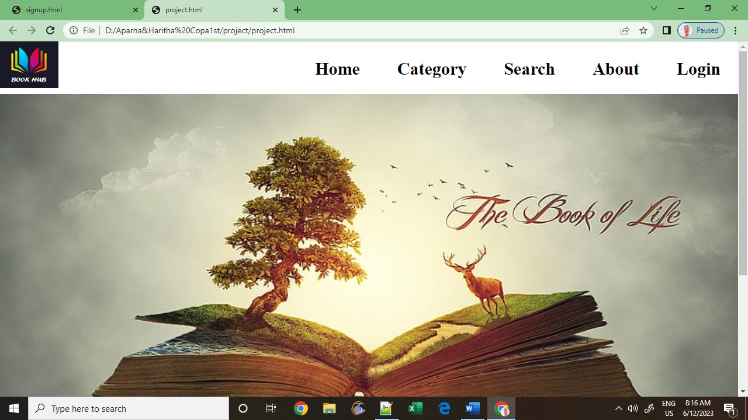

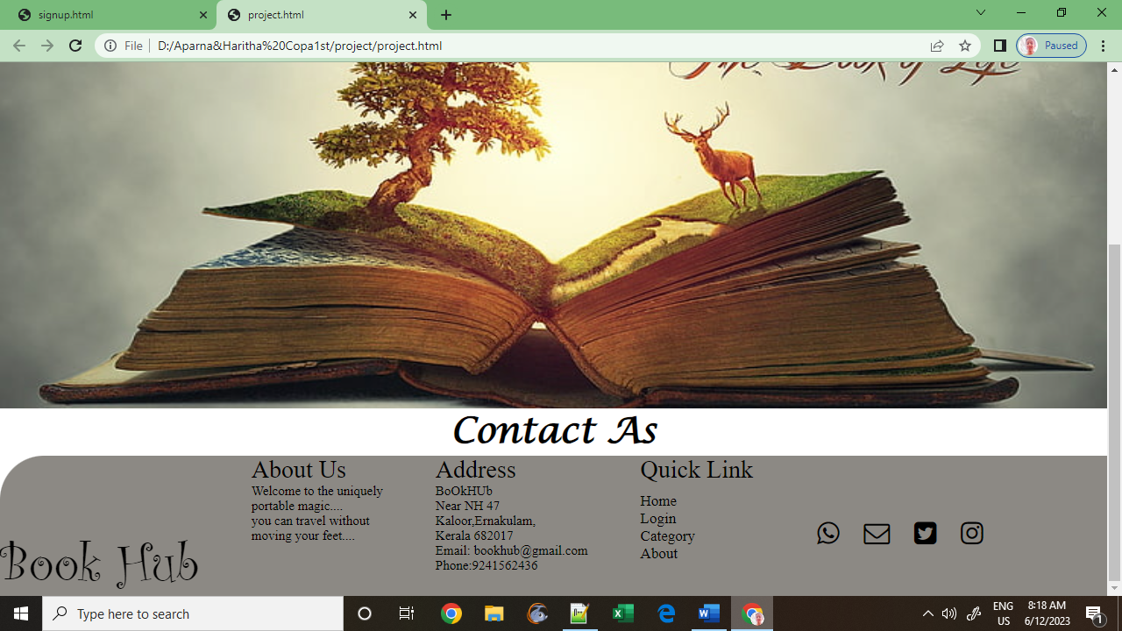

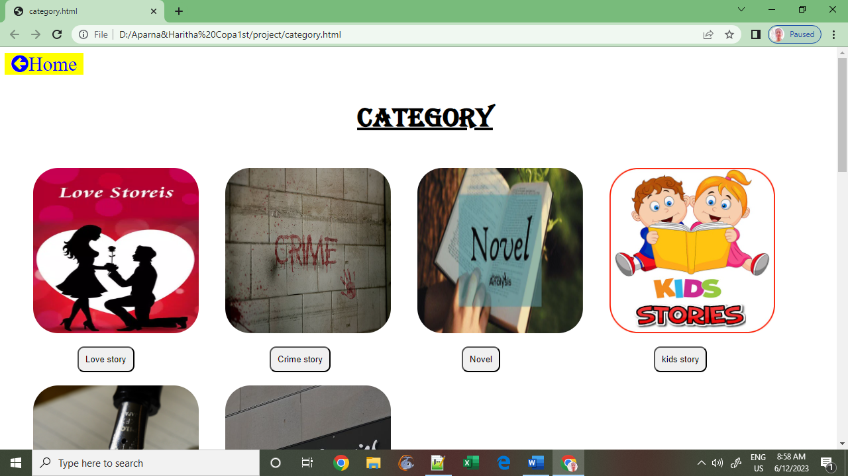

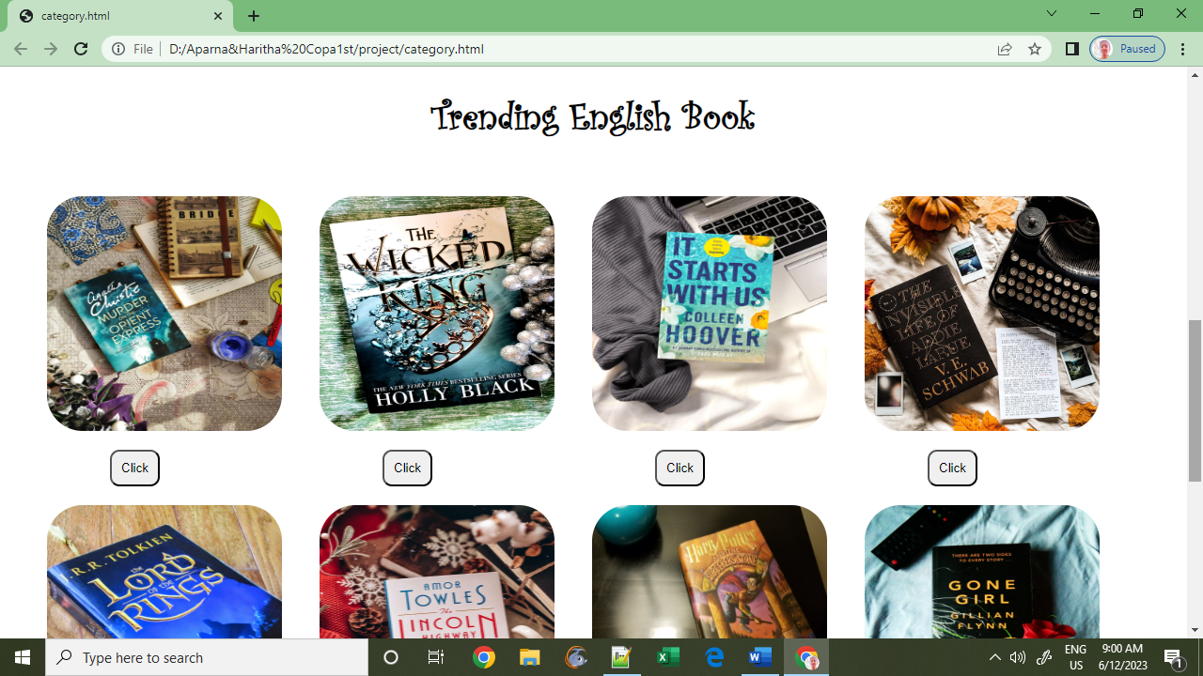

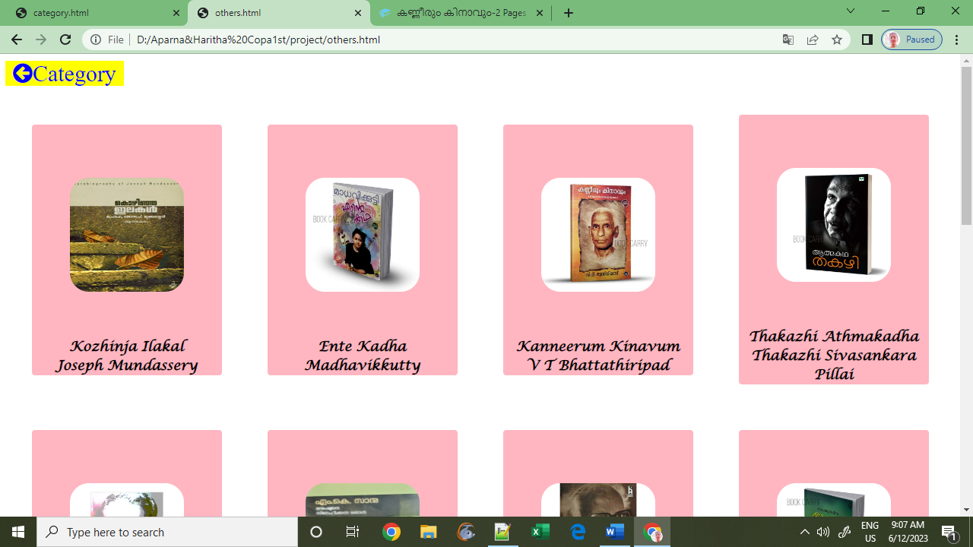

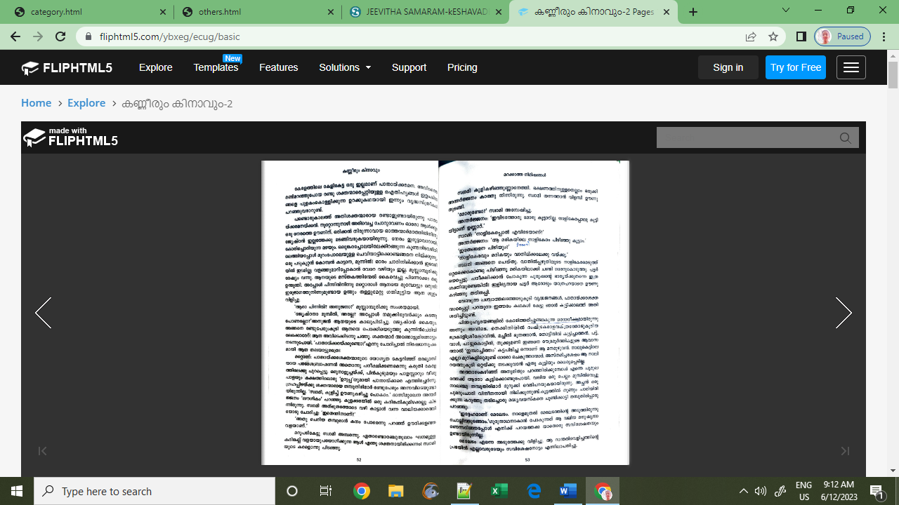

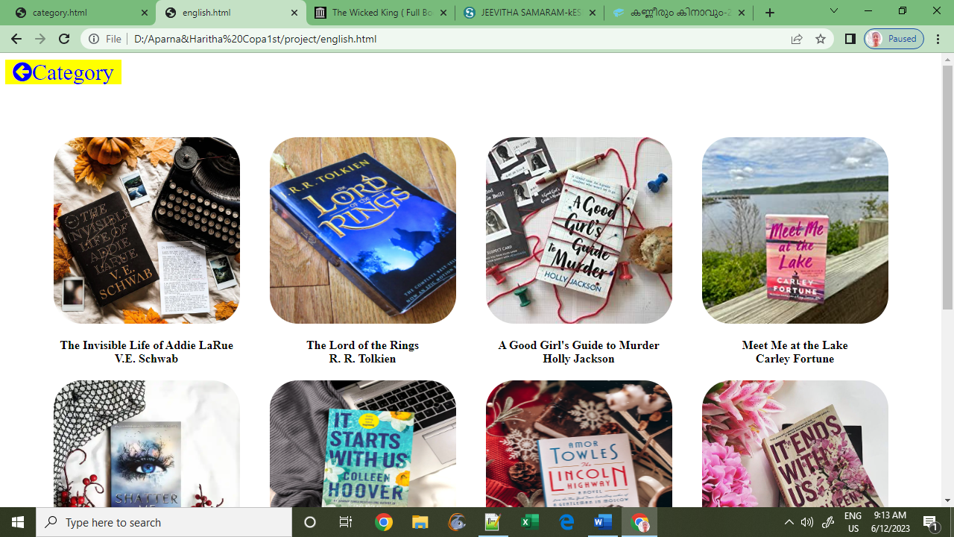

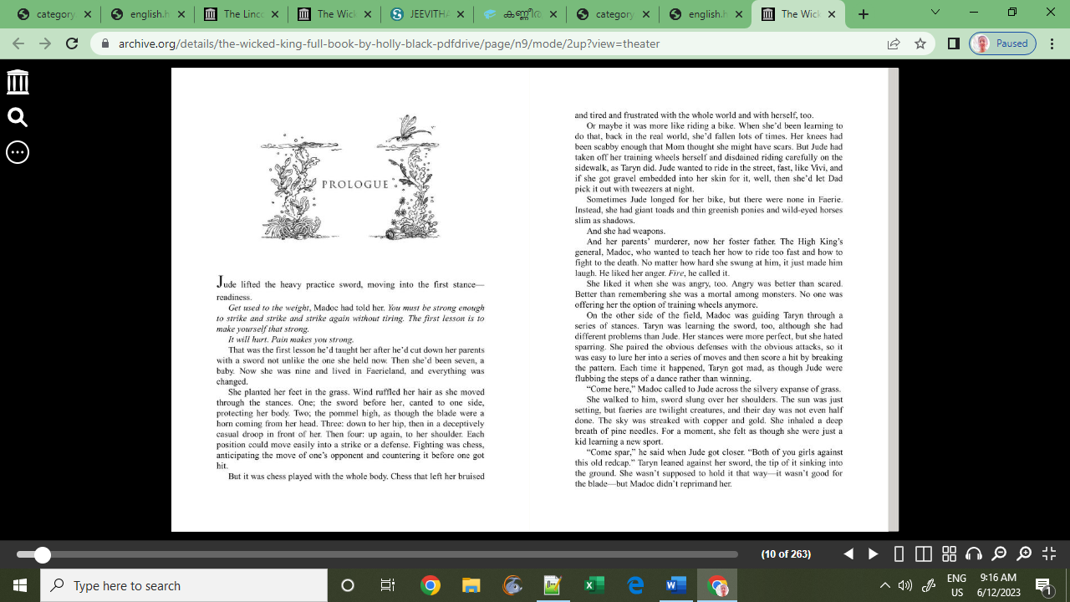

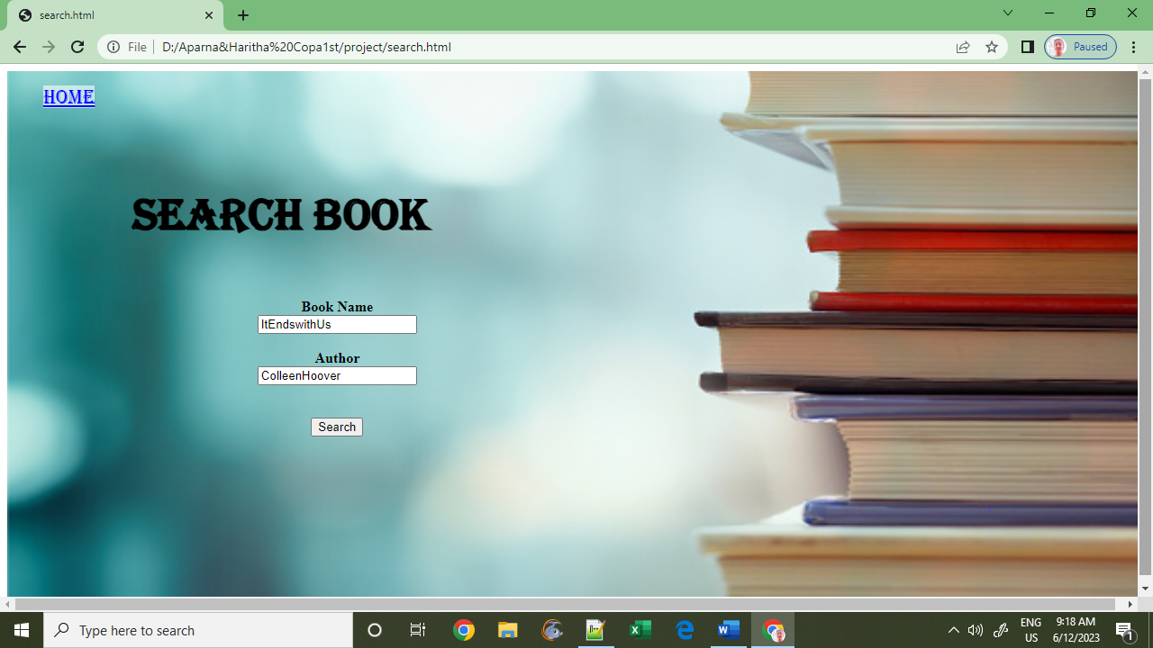

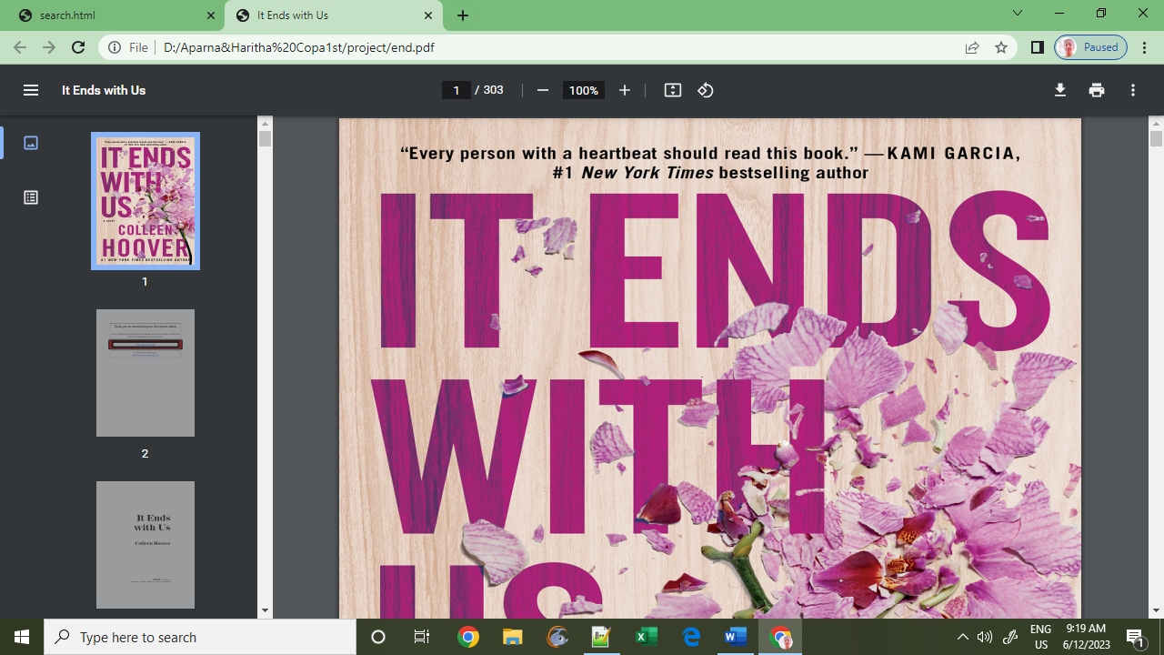

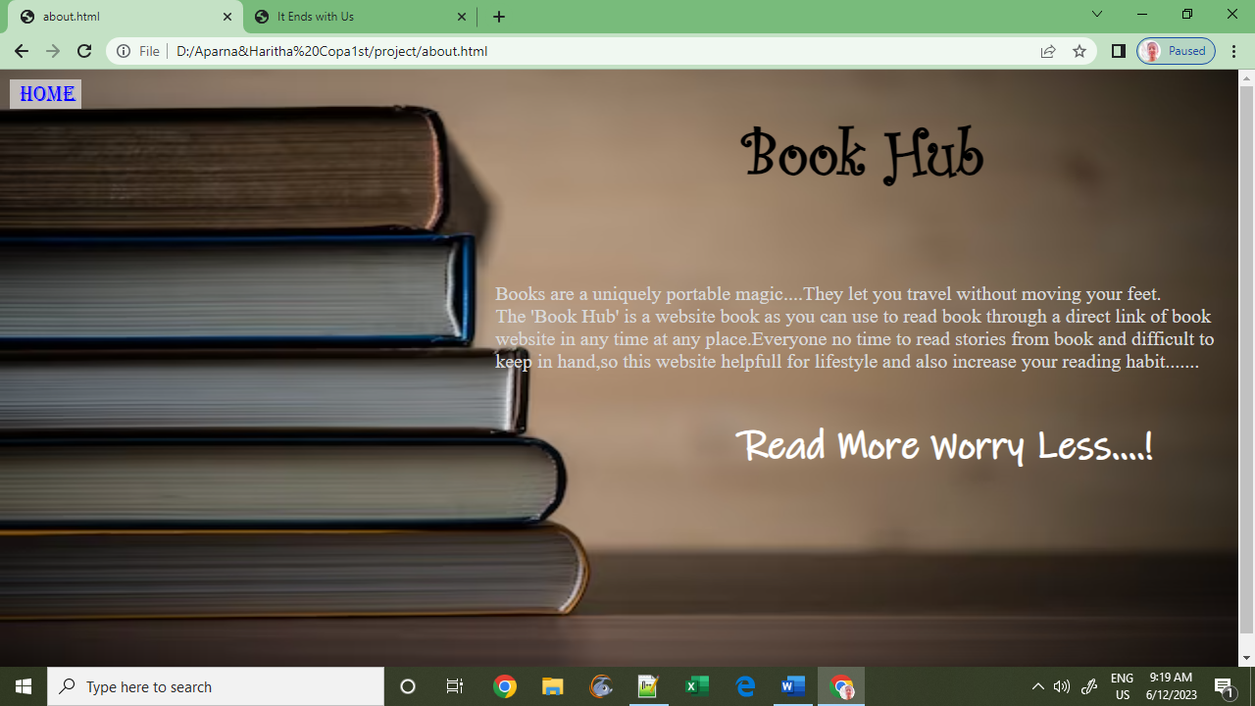

Login

<html>

<head>

<link rel="stylesheet"href="code.css">

<link rel="stylesheet" href="https://cdnjs.cloudflare.com/ajax/libs/font-awesome/4.7.0/css/font-awesome.min.css">

</head>

<body>

<center>

<img class="bck2" src="ef.jpg">

<form class="form">

<h1 class="lo">LOGIN</h1>

Email/Phone number<br>

<input id="email"><br><br>

Password<br>

<input type="password" id="pswd"><br><br>

<i class="fa fa-eye-slash" id="ey" onclick="pse()"></i><i class='fa fa-eye' id='v-eye' onclick="pse()"></i>

<div><input class="but" type="button" onclick="validation()"name="Submit" value="Submit"></div>

<div><a href="login.html" class="sign">SingIn</a>

<a href="signup.html"class="sign" >SignUp</a></div>

</form>

</center>

<script src="validation.js">

</script>

</body>

**</html>**